Summer 2018 Fitness Class Descriptions

ARMs+X: Cross training class focused on blasting the biceps, triceps, and shoulders with HITT cardio blast!
Body Pump: A full body strength training class incorporating hand weights, bands, bars, and body weight exercises.
Cardio & Core: Intermediate level interval training style class that includes kickboxing, Zumba, strength training, and core type exercise.
Fusion 45: Intermediate strength and cardio class for the middle age adult to high fitness level senior participant. Monday/Tuesday will be a combination of Upper Body Fitness and Cardio. Wednesday/Thursday will be a combination of Lower Body Fitness and Cardio.
FitX: The next generation of group strength training and H.I.I.T type class combined. Class incorporates bar, hand weights, body weight, bands, balls, and disk. FYT-X class will take you to the next level of FITNESS! Stop paying a Personal Trainer and get FitX trained!
Indoor Cycling/Cycling-X: A popular group cycling class that will work you through the 5 energy zones. As you pedal, motivational music plays and the instructor talks you through a visualization of an outdoor cycling workout. Classes are designed to improve cardiovascular fitness, endurance, and strength. Classes are 40-50 minutes in length.

PowerVix: Party to the latest songs and build confidence all while getting a body changing workout. PowerVix combines intense cardio dance moves with body sculpting for a fun and effective workout experience!

SilverSneakers Circuit: Improve heart health and muscular endurance. Non-impact exercises including upper-body strength work are safe and effective even if you have cardiac or respiratory problems.

SilverSneakers Classic: Exercise at your own pace with resistance tools including bands, balls, and weights. Class will include chair and standing exercise to improve overall health.

Yoga: A fun fitness class that teaches postures, body alignment, breathing techniques and stress relief. Yoga helps improve the cardiovascular system; strengthens bones, muscle and tendons; increases flexibility; and improves balance. Yoga is the complete mind/body workout. Yoga +: includes power type moves. Gentle Yoga is a restorative yoga.

Zumba: The Latin-inspired, easy-to-follow, calorie-burning, dance-fitness party. Feel the music and let loose!

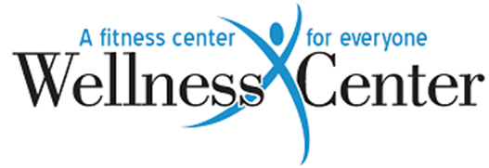
Classes Free with Membership.
Unlimited Classes $25/month. Single Class $3.00.
***Separate fees for some specialty type classes***
912.383.6988

