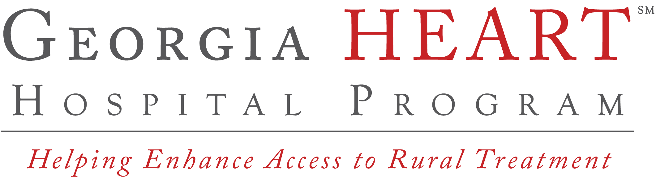
Contribute to your local rural hospital for a 100% Georgia income tax credit!

Follow these five simple steps to give your
rural hospital donation a booster shot in 2019:

- If you pay Georgia income taxes, you are eligible to receive a tax credit for contributing to your designated rural hospital organization as follows:
- Individual Filer – 100% of the amount contributed, up to a limit of $5,000
- Married Filing Jointly – 100% of the amount contributed, up to a limit of $10,000
- Pass-Through Entity – 100% of the amount contributed, up to a limit of $10,000, so long as they would have paid Georgia income tax in that amount on their share of taxable income from the pass-through entity
- C-Corporation or Trust – 100% of the amount contributed or 75% of your Georgia income tax liability, whichever is less

How much can I contribute for a tax credit?
Submit your 2019 HEART Tax Credit Form online beginning October 1st, 2018 at www.georgiaheart.org.

