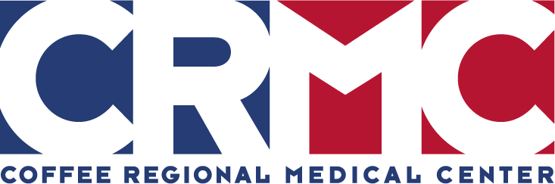

RISE-UP CAREER DEVELOPMENT LADDER PROGRAM: LETTER OF INTENT
Program Date: January 1, 2026 – December 31, 2026
Employee’s Full Name:
Employee Badge #:
Employee Email Address (work) and a Cell Phone # you wish to be contacted at.  Note that you must check your emails to remain informed. | Work Email:  Cell Phone Number:
Career Development Ladder Program You Wish to Apply For:  Please read all the career development ladder requirements on page 5 of the program packets to ensure you qualify for the program. | ☐ Rising Star  ☐ Shooting Star  ☐ Super Star
What Level will you be looking to complete this year?  You must have completed the previous level, for example you must have complete level 1 & 2 to apply for level 3. | ☐ Level 1  ☐ Level 2  ☐ Level 3  Are you repeating the same level as a previous year: YES NO
Have you previously participated in RISE-UP Program? If yes, what program & level did you last complete? | ☐ No, this is my first time participating (skip next question)  ☐ Yes, but I did not complete the program and wish to start again.  ☐ Yes, and I completed the program (answer next question)
Did someone refer you to the program?
What was the last program you completed? I last completed _____________ Star, Level _____ (Year _______)
EMPLOYMENT INFORMATION  Employee Status: | ☐ Full-Time (working 36 or > hours per week)  ☐ Part-Time # hours:  ☐ PRN (averaging 500 hours a year)
Date Employment began at CRMC (must be employed 6+ months to apply):
Years of Experience at CRMC:
RESUME MUST BE ATTACHED IN ORDER FOR LETTER OF INTENT TO BE ACCEPTED.
Employee Signature:
Department:
Number of Departmental Inservice Hours Required for program applied for:
Department Manager Signature:
Date Submitted:
Note: Forward your completed Letter of Intent & Resume with subject “RISE-UP Letter of Intent” to Sarah Brown, Sarah.Brown@coffeeregional.org. Letter of Intent for 2026 program due Friday, January 23, 2026. Kick-off meeting dates will be announced soon.

